# Chapter 3 Programming Project

**Content**

**Problem decomposition**

**Management of complexity**

By the end of this activity you will have created quite a complex program. But notice how the activity takes you through the smaller steps in building the program?

The finished program is broken up into smaller steps, then they’re each completed individually. When they’re put together they create the larger program. This type of decomposition allows the programmer to manage complexity. Rather than considering the whole problem and program, the programmer can focus on each small component, then assemble them together at the end.

Writing programs with methods allows us to divide the program up into smaller parts quite easily.

Complete this programming project using your notes, the text book, and any online or in-class sources you like. Your work must be your own; you may ask a friend to look over your work, or discuss procedural decomposition with you, but you must write all code on your own. Don’t forget to use your 4 commandments of scope and error-checking algorithm.

**To receive full credit on this lab, you MUST submit a structure diagram or pseudocode-plan with each question.**

Exercise 1

*Princess Luna and Celestia are going on a tour of the kingdom to greet the other citizens of Equestria. Their tour takes them on a circular path (shown on map on next page). Write a method called roadTrip that (1) accepts as a parameter the diameter of the circular path, and (2) returns the length of the trip. Hint: Your main method should call the roadTrip method with a parameter.*

*The equation for circumference is: C = dπ*

*Java has a math constant called Math.PI.*

Exercise 2

*Write a method called distance that (1) accepts four integer coordinates: x1, y1, x2, y2 as parameters, (2) computes the distance between points (x1, y1) and (x2, y2) on the map, and (3) returns that distance.*

*The equation for the distance is: $d= \sqrt{{(x2-x1)}^{2}+ {(y2-y1)}^{2}}$*

*Test out your program by writing a main method that calls the distance method for each of the following pairs of cities. Your main method should output the value returned by the distance method.*

*Distance from Baltimare (29, 16) to Manehattan (34, 8)=*

*Distance from Los Pegasus (6, 19) to Neighagra Falls (22, 7)=*

*Distance from the Badlands (25, 24) to Ponyville (16, 14)=*

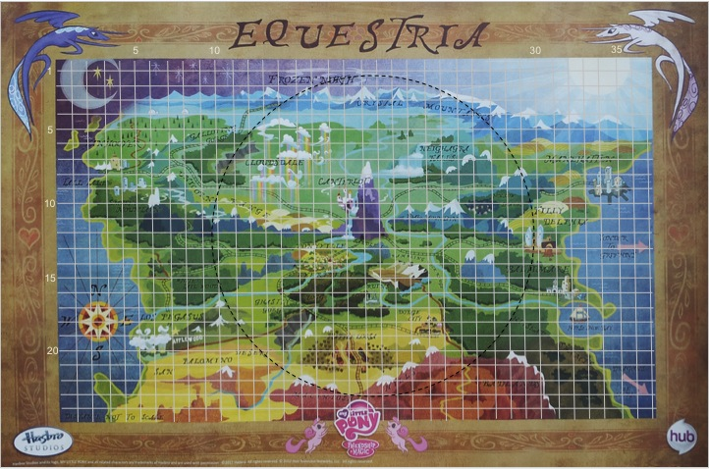

## Exercise 3

*Write a program that helps Princess Luna plan a 3-stop tour of Equestria. Princess Luna has specifically requested that you choose three destinations in Equestria, as defined by their x and y coordinates on the map. You program should output the distance between the three.*

*You should use the distance methods you wrote for Exercise 2.*

Exercise 4

*Write a method called totalTrip that accepts parameters for 3 locations (each containing coordinates) and returns the total distance traveled by visiting all 3 locations and returning to the starting location. You should use the distance methods you wrote in Exercise 2 and you can choose any 3 locations in Equestria.*

*Extra credit: make this program compute 4 locations instead!*

**Big Ideas**

**Tools and technologies can be adapted for specific purposes.**

The ability to determine the distance between two points is a valuable feature in a program. There are a number of projects where this type of ability would be useful, including planning efficient trips, star mapping, or even figuring out where to place cell phone towers.

As you complete more projects in the course, think carefully about how your projects can be reused and repurposed in order to solve other problems.